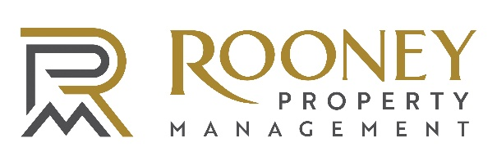
About Rooney Property Management
Rooney Property Management is a team of experienced, proactive professionals dedicated to delivering high-quality property management and an exceptional resident experience. With a strong foundation in managing diverse residential properties, the team focuses on creating communities where residents feel at home from day one.

At RPM, collaboration and thoughtful decision-making are at the core of everything we do. Each team member brings a unique perspective and expertise, allowing us to approach challenges strategically while keeping resident satisfaction front and center. From individual units to community-wide initiatives, we are committed to maintaining well-managed properties and fostering positive, lasting relationships with our residents.

Property Housekeeper
Rooney Property Management is seeking dependable, detail-oriented individuals to join our team as Property Housekeepers. This position plays a key role in maintaining a clean, safe, and welcoming environment throughout our apartment communities. Our residents expect a luxury-level standard of cleanliness and presentation, and we are looking for team members who take pride in delivering exceptional results every day.
The ideal candidate is professional, reliable, and motivated, with a strong attention to detail and a commitment to maintaining high community standards.
Position Details
- Full-time, 40 hours per week and or Part- time
- Daytime schedule, Monday–Friday
- Weekend rotation as needed
- Position includes shift transitions between morning, afternoon, and evening coverage
- Currently hiring multiple individuals for this role
Essential Responsibilities
- Perform daily cleaning of interior common areas including:
  - Lobbies
  - Hallways and corridors
  - Stairwells and elevators
  - Fitness centers
  - Clubhouses and amenity spaces
  - Public restrooms
- Complete daily valet trash pickup outside apartment units
- Maintain a polished, luxury appearance throughout the property
- Clean and sanitize high-touch surfaces including:
  - Door handles
  - Railings
  - Elevator panels
  - Fitness equipment
- Maintain glass, mirrors, stainless steel, and other high-end finishes
- Vacuum, sweep, mop, and maintain flooring surfaces including tile, LVP, carpet, and concrete
- Assist with apartment turnover and make-ready cleaning to ensure units are move-in ready
- Identify and report maintenance concerns, safety hazards, or property damage promptly
- Safely use cleaning chemicals and equipment in accordance with OSHA and SDS guidelines
- Restock cleaning and restroom supplies and communicate inventory needs to supervisors
- Maintain housekeeping equipment in clean and safe working condition
- Respond professionally to resident and management requests
- Collaborate with maintenance and management teams to uphold community standards
- Perform additional duties as assigned
Qualifications
- Previous housekeeping, hotel, janitorial, commercial, or apartment cleaning experience preferred
- Experience working in luxury residential or hospitality environments is a plus
- Strong attention to detail and organizational skills
- Ability to follow cleaning procedures and safety guidelines
- Ability to work independently and as part of a team
- Professional, dependable, and punctual
- Strong work ethic with pride in quality workmanship
- Ability to lift up to 40 pounds and remain on your feet for extended periods
Employee Perks
- PTO package plus paid holidays
- Low-cost health, dental, and vision insurance
- 401(k) with employer match
- Employer-paid life insurance and long-term disability
- Scholarship opportunities
- Friendly and supportive team environment
- Clean, modern workplace
Compensation
Competitive pay based on experience.

To apply, please submit your resume to tarah@keyholecapitalllc.com

